Math 8 Application 3 Name ________________________
Show all your work!

1. Circle the letter that represents the approximate location on the number line of $\sqrt{53}$.  A B C D  0 5 10 15 | 2. Simplify without a negative exponent:  5⁻² = | 3. Solve for x:  x³ = 64
4. Write in scientific notation.  12,500,000 | 5. Write the difference in scientific notation.  (4.2 ∙ 10⁵) - (5.8 ∙ 10⁵) = | 6. Solve for x.  2x – 25 = 12x + 7
7. What type of transformation of Figure A resulted in Figure B?  A  B | 17. Find the length of side a below.  a 20 in.  15 in. | 9. Find the measure of angle b.  b  37◦
10. Put the following rational numbers in order from smallest to largest.  -⅞, -⅖, -.27, -.78 | 11. Estimate the sum below.  2,456,890 + 678,945 | 12. Write as percent.  1.5
13. Seneca made a pattern with toothpicks as shown below. Write an equation to describe the function.    Stage 1 Stage 2 Stage 3 | 14. Graph Seneca’s function.  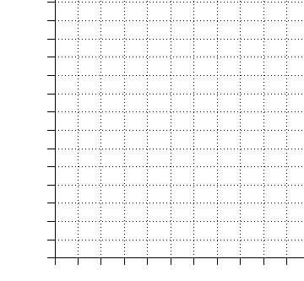 | 15. Complete the table.
  Stage | Total toothpicks
  1
  2
  3
  5
  10
16. At Julie’s store, if she increases the price of her product by 30% in order to make a profit, what should she sell a product for that cost her $50? | 17. What is the volume of a sphere with a radius of 5 cm? | 18. A framer used 540 nails in 45 minutes. What was the rate of use of nails per minute?
19. Juan’s quiz scores are 3, 8, 5, 9, and 10. What is the mean of his quizzes? | 20. The inchworm traveled 4 feet one day and then 24 inches the next day. How many total yards were traveled? | Number correct  5 minutes_______  Total___________

